- Inter-VLAN Routing Basics Theory

Q1. In Cisco Packet Tracer, create three VLANs named Foodies, Shoppers, and Streamers to represent users of Zomato, Flipkart, and Spotify, and assign at least one PC to each VLAN?

Answers
- I created three VLANs in Cisco Packet Tracer using a 2960 switch.
- I named VLAN 10 as Foodies, VLAN 20 as Shoppers, and VLAN 30 as Streamers.
- I assigned FastEthernet0/1, Fa0/2, and Fa0/3 to VLAN 10, 20, and 30 respectively.
- I verified the configuration using the show vlan brief command.
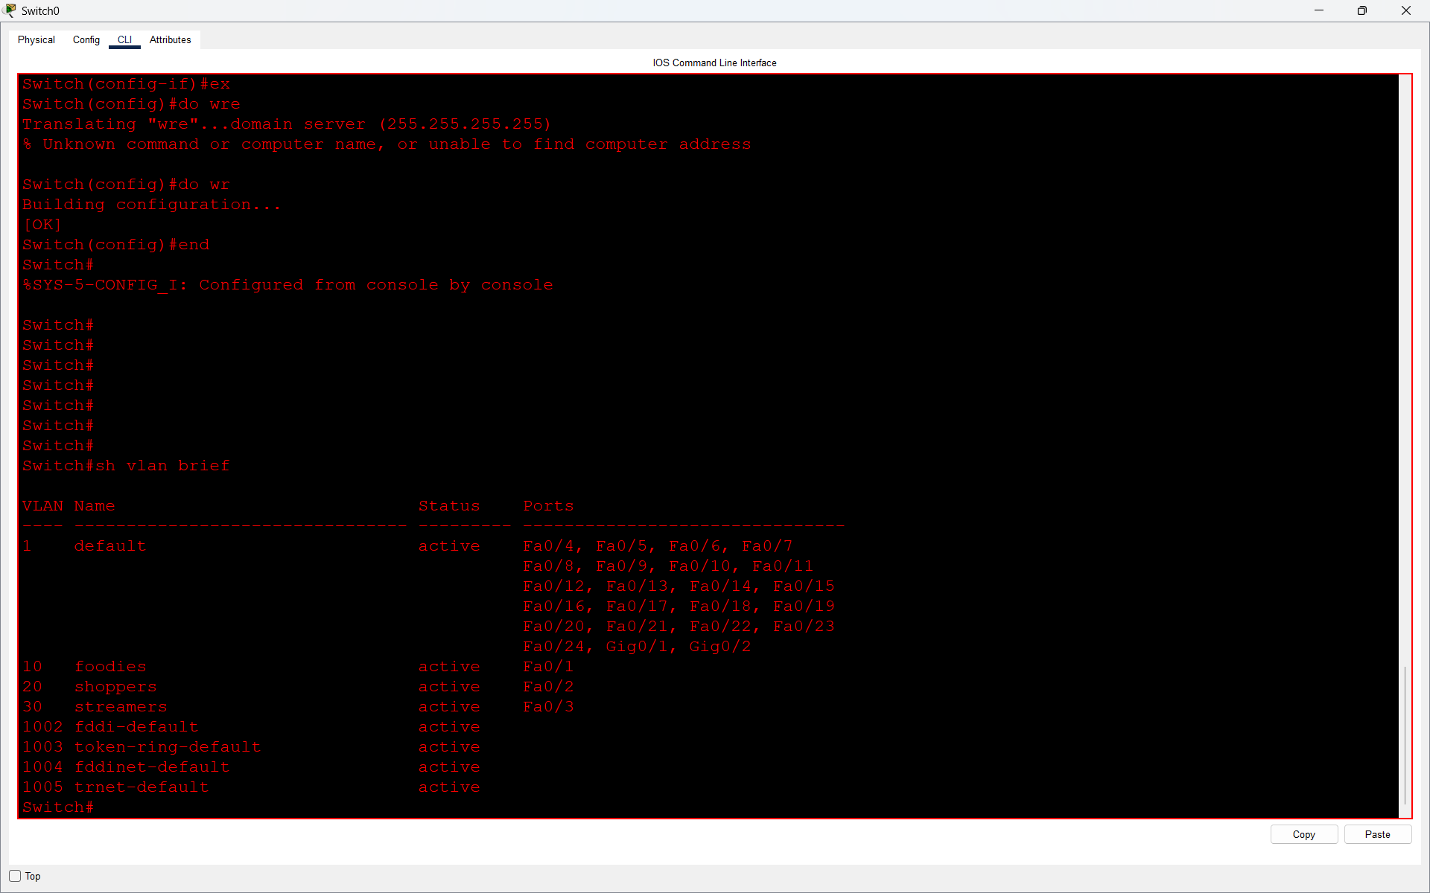
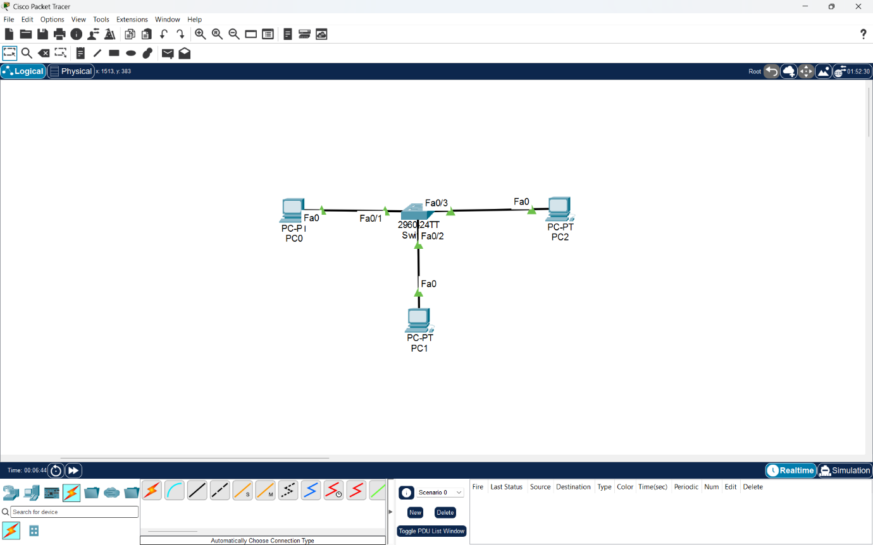

Q2. Configure a router-on-a-stick setup in Packet Tracer so that PCs in the Foodies, Shoppers, and Streamers VLANs can all ping each other using sub-interfaces on the router (e.g., GigabitEthernet0/0.10, .20, .30)?

Answer
- I configured Router-on-a-Stick using a Cisco 2811 router and a 2960 switch.
- I created three sub-interfaces (Fa0/0.1, Fa0/0.2 and Fa0/0.3) for VLANs 10, 20 and 30 using 802.1Q encapsulation.
- I assigned IP addresses 199.168.1.1, 199.168.2.1 and 199.168.3.1 to the sub-interfaces.
- I verified the configuration using the show ip interface brief command, and all three sub-interfaces were up.
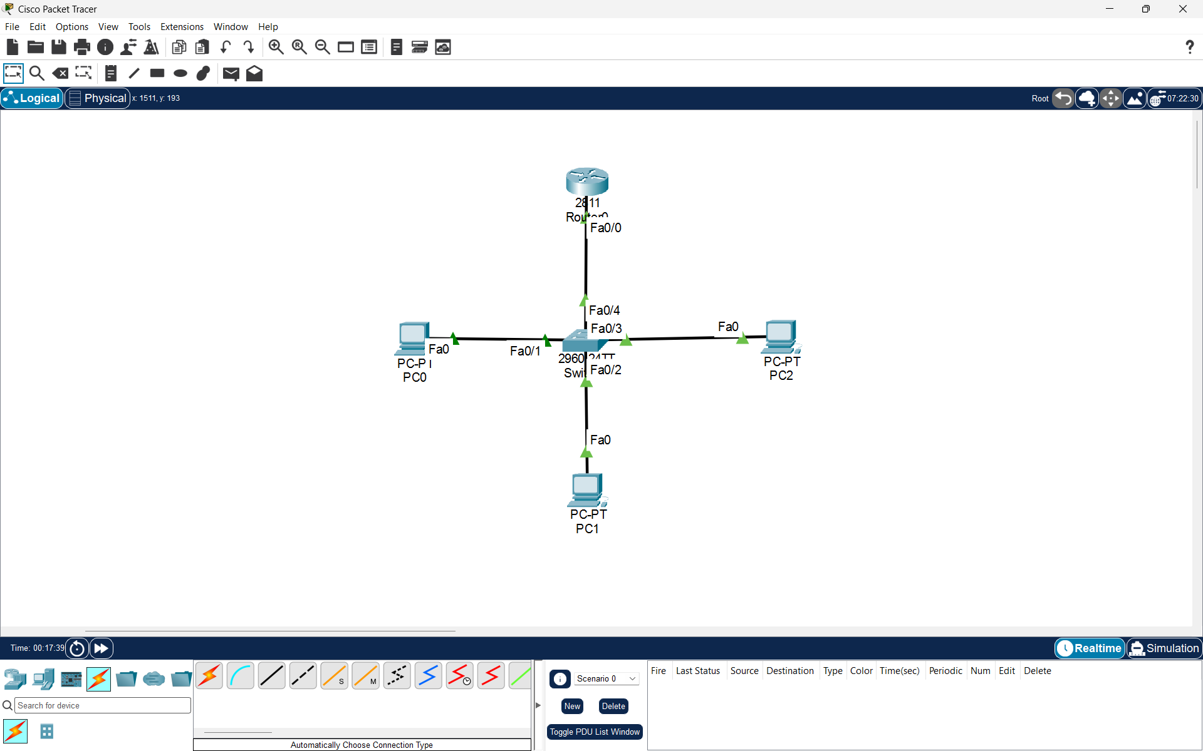

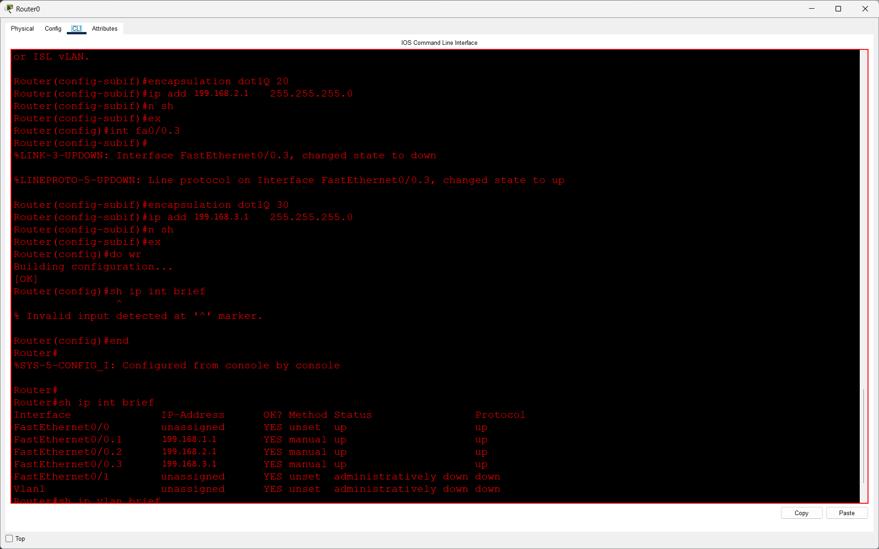

Q3. Assign IP addresses to each PC in your VLANs and set their default gateways to the corresponding router sub-interface IPs to enable inter-VLAN communication?

Answer
- I assigned static IP addresses and default gateways to the PCs in VLAN 10, VLAN 20, and VLAN 30.
- I configured the default gateways according to the router sub-interface IP addresses.
- I tested inter-VLAN connectivity using the ping command. Communication between the Foodies and Shoppers VLANs was successful.
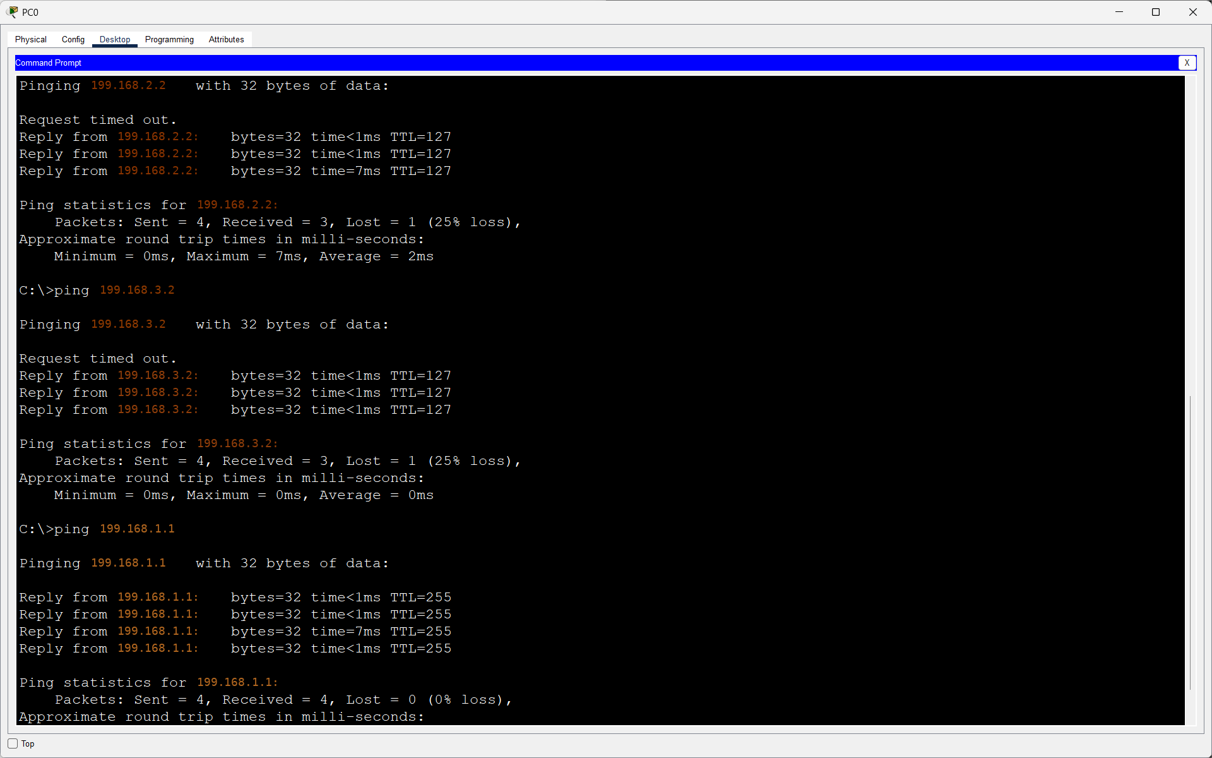

Q4. Simulate a scenario where users in the Shoppers VLAN (Flipkart) cannot ping users in the Streamers VLAN (Spotify). Identify and fix the misconfiguration causing the issue, then verify connectivity.<br><br><em><strong>Hint:</strong> Check VLAN assignments, router sub-interface configurations, and trunk port settings.</em>?

Answer
Q4. Answer:
- I simulated a connectivity issue between Shoppers VLAN 20 and Streamers VLAN 30 by changing the router sub-interface encapsulation to VLAN 40.
- The ping failed with 100% packet loss.
- I corrected the misconfiguration using the encapsulation dot1Q 30 command.
- After fixing it, the ping was successful with 0% packet loss.

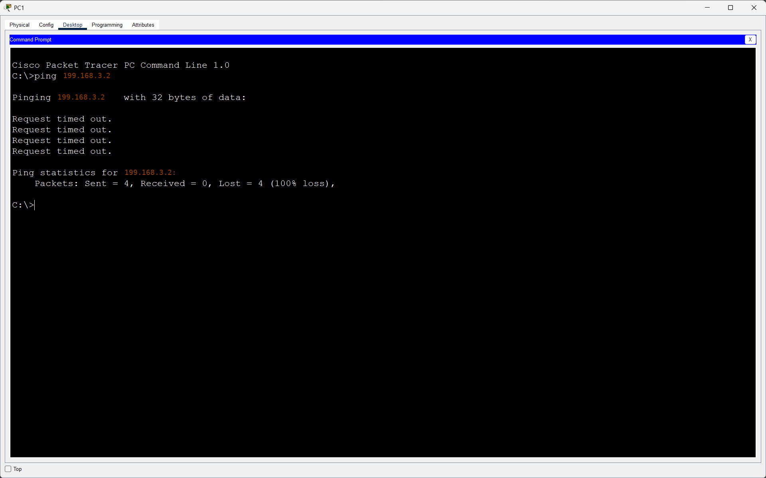

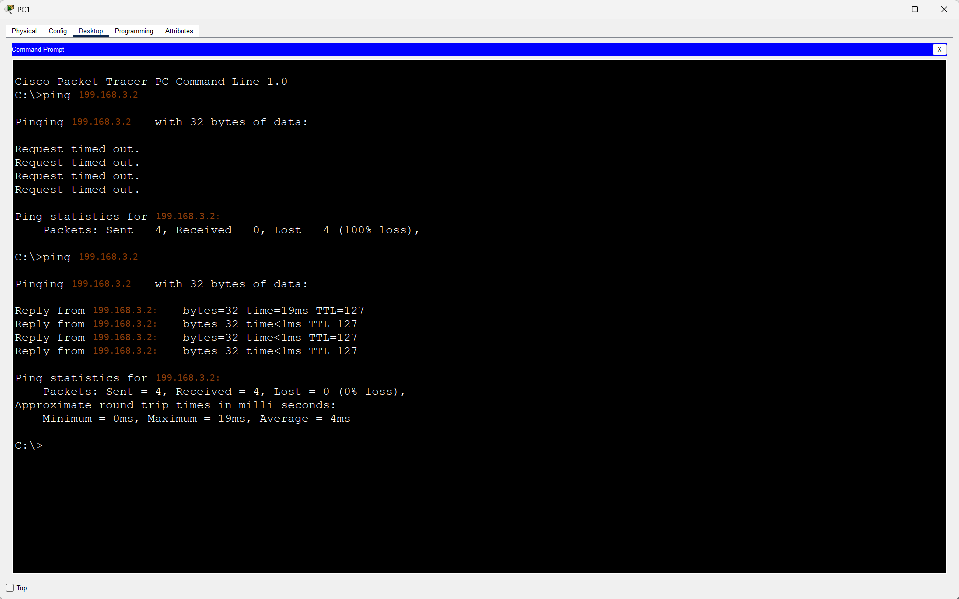

Q5. Compare the router-on-a-stick method you just configured with inter-VLAN routing using a Layer 3 switch: list two advantages and two disadvantages of each approach in a table?

Answer
Method | Advantages
  Disadvantages
- Router-on-a-Stick | 1. Easy to configure for small networks. | 1. All inter-VLAN traffic uses one physical router link, which can cause congestion.
 |  | 2. Slower performance compared to Layer 3 switching.
  2. Can use an existing router, reducing hardware cost.
- Layer 3 Switch | 1. Provides faster inter-VLAN routing using hardware switching. | 1. Usually more expensive than a basic Layer 2 switch.
 | 2. Suitable for large networks with many VLANs. | 2. Requires more networking knowledge to configure and manage.

- Conclusion: Router-on-a-Stick is suitable for small networks, while Layer 3 switches are generally better for larger networks requiring faster inter-VLAN communication

